Chapter 23: How probable is probable? Paragraph with uncertainty words

Arthur was worried. It was almost certain there would be a maths test today, and he hadn’t been paying much attention recently. Sally would probably get more marks than him, but there was a distinct possibility that Zak would mess up. The weather forecast said it might rain, so he took a coat, and as he walked to school he thought he was likely to meet Zak, who always played around, and could make him late. If he were late, he was certain to get into trouble. Perhaps there would be a fire drill to disrupt the test? But really there was little chance of that, and it was also extremely unlikely an asteroid would hit the school. It was going to be a bothering sort of day.

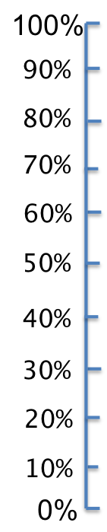
Underline the words or phrases that express uncertainty, such as ‘could’, ‘likely’ etc. Make a list of these words, and rank them in terms of highest to lowest probability. Put each word on the vertical probability scale below, for example if you think that ‘almost certain’ is near 50%, write it next to 50%.

