Chapter 21 What does random look like?

In the four pictures of 9 x 9 grids of colours below, the colours were chosen at random from a palette of nine colours in three of them. In one of them, the colours have been very carefully chosen to form a very special pattern. Which is the non-random one? What pattern does it have?

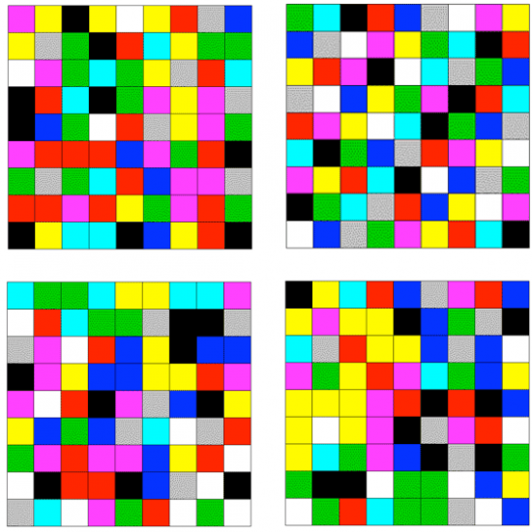

Background
The grid on the top right represents a symmetric Sodoku solution: each colour occurs once in each column, row, 3x3 sub-square, position in a sub-square, ‘broken row’ and ‘broken column’ (a broken row, for example, is a set of 3 corresponding mini-rows in 3 vertical sub-squares) – see figure on left.
 |  |  |  |  |  |  |  | 7
 |  |  |  | 7
 |  | 6
 |  | 4 |  | 3
 |  |  | 1 | 5 |  |  |  | 8
 |  |  |  |  | 2 |  | 7
 |  |  |  |  | 1 | 4
 |  |  |  |  | 4
1

There are only two such symmetric Sodoku solutions (up to appropriate permutations): this one can be completed after specifying the 14 entries shown on the right.

This is a very special case of a Latin square, in which each colour occurs once in each row and column, investigated by Euler and adapted by Ronald Fisher FRS and Frank Yates FRS for use in the layout of crop varieties in agricultural experiments. Behrens introduced the idea of gerechte designs in 1956, in which each of n varieties would also appear only once in a sub-area of size n, and in 1977 John Nelder FRS posed the problem of uniquely completing a Latin square from a critical set of entries. Howard Garns put these ideas together in 1979 as a number place puzzle, which in 1986 became popular in Japan under the name Sodoku.

A Sodoku puzzle is therefore, in formal terms, a critical set for a gerechte design for the 9x9 grid partitioned into 3x3 subsquares. Robert Connelly proposed a symmetric Sodoku with the properties shown in the glass, and Bailey, Cameron and Connelly proved there are only two such patterns using an elegant combination of coordinate geometry and coding theory.

